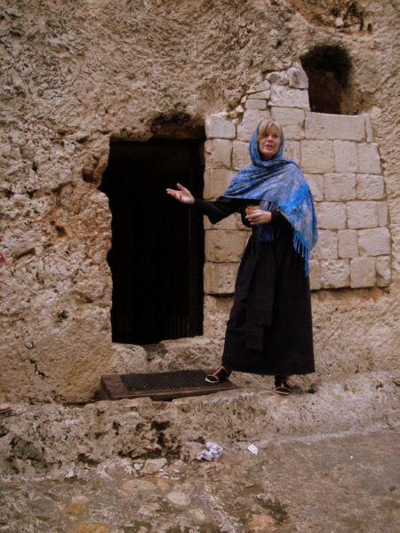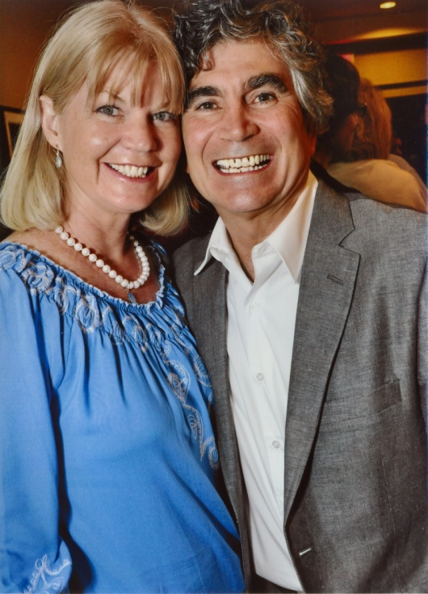

**Your Information Here Time, Place, Date, Phone**

**Or if you choose not to, you Can delete this text box and**

**Stretch the picture of to fit**

**Dramatic Christian Ministries**

**~ Narrow Gate Theater ~**

The Acts of the Holy Spirit ~ Transforming Lives

“Resurrection”

Day ONE

Dennis & Wendy Cole

***http://dcministries.com***

***Albuquerque, NM***

***Enter through the narrow gate. For wide is the gate and broad is the way that leads to destruction, and many enter through it. But small is the gate and narrow the way that leads to life, and only a few find it.  - Matthew 7:13-14***

***Wendy & Dennis Cole***

Bible Drama, Theater, Film, Radio, TV, Scripts, Acting School

For more information visit our website