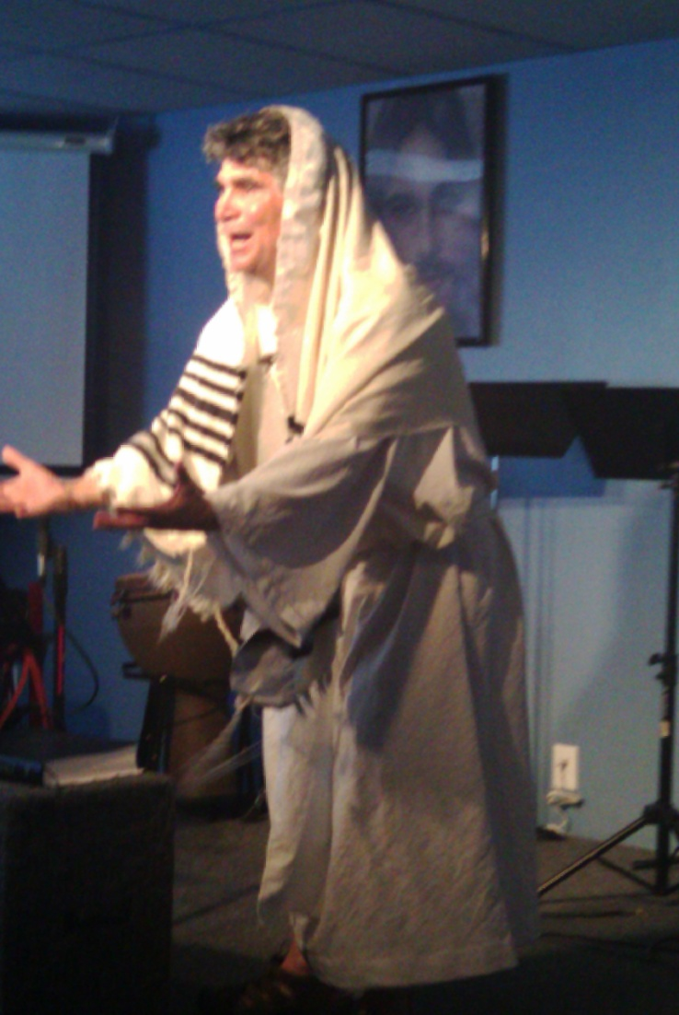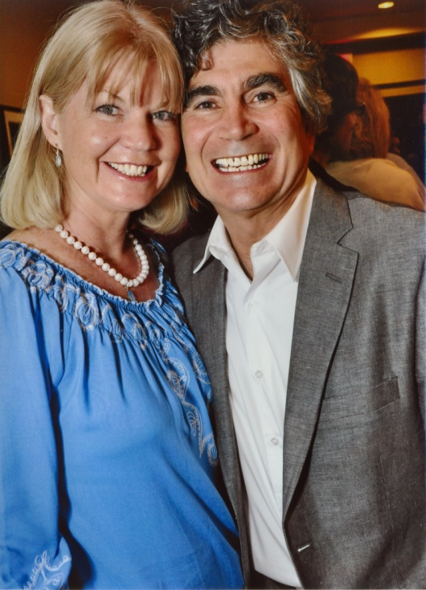

**Day & Time**

**Sermon on the Mount**

**Matthew 5 – 7**

**Day & Time**

**The Book of James**

**James 1 - 5**

**Day & Time**

**God’s Grace & Israel’s Place**

**Romans 9 - 11**

**Day & Time**

**Acting ONE**

**John 15**

**Day & Time**

**Temple & Olivet Discourse**

**Day & Time**

**Matthew 23- 25**

**PLACE**

Presents:

Renewal Week Theatre

With Dennis Cole

***http://dcministries.com***

***Albuquerque, NM***

***Enter through the narrow gate. For wide is the gate and broad is the way that leads to destruction, and many enter through it. But small is the gate and narrow the way that leads to life, and only a few find it.  - Matthew 7:13-14***

***Wendy & Dennis Cole***

Bible Drama, Theater, Film, Radio, TV, Scripts, Acting School

For more information visit our website

**Dramatic Christian Ministries**

**~ Narrow Gate Theater ~**

The Acts of the Holy Spirit ~ Transforming Lives