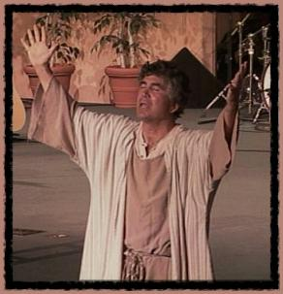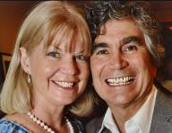

Dennis Cole as Paul

Bible Drama, Film, Theater, Radio, TV, Scripts, Acting School

For more information visit our website

The Acts of the Holy Spirit ~ Transforming Lives

YOUR INFORMATION

IN THIS BOX

TIME  DATE

PLACE

PHONE

Or, if you prefer, you can

delete this box and

make the

photo of

Dennis bigger to fit

**Wendy & Dennis Cole**

***Enter through the narrow gate. For wide is the gate and broad is the way that leads to destruction, and many enter through it. But small is the gate and narrow the way that leads to life, and only a few find it.  - Matthew 7:13-14***

http://dcministries.com

dcministries@dcministries.com

505-831-0311

“Paul In Prison”

I am ready to die if it is necessary. The Holy Spirit has been warning me that in every city that I am going to be imprisoned

and suffer hardship. But I want to finish the race and complete the task and preach the gospel of the Lord Jesus Christ even

though it means imprisonment

and hardship

and eventually death.

**Dramatic Christian Ministries ~ Narrow Gate Theater ~**