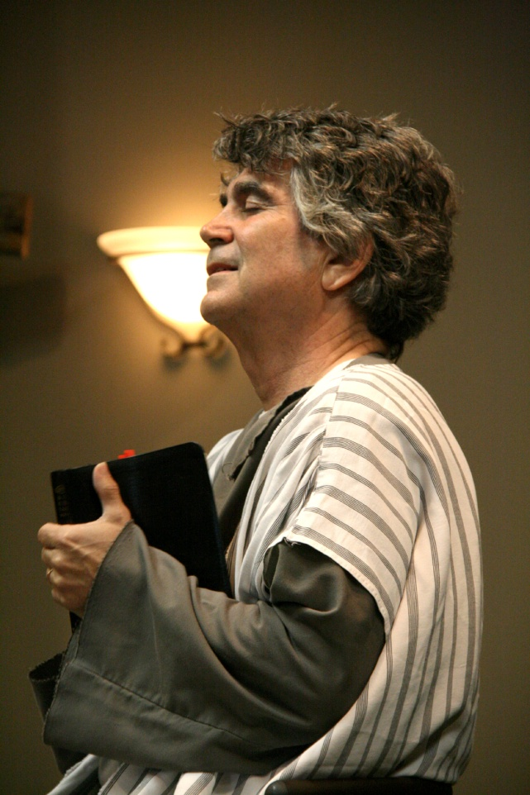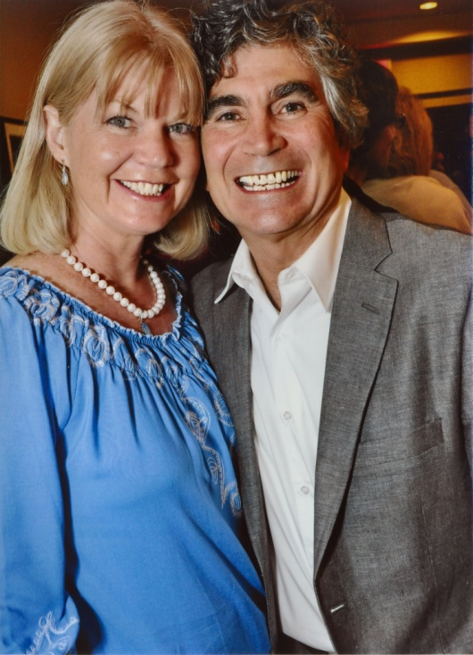

Your info here

Place, time, date

Phone, etc.

Or if you prefer, you

Can delete this text box and

Stretch the picture of Dennis to fill the space

***http://dcministries.com***

***Albuquerque, NM***

***Enter through the narrow gate. For wide is the gate and broad is the way that leads to destruction, and many enter through it. But small is the gate and narrow the way that leads to life, and only a few find it.  - Matthew 7:13-14***

***Wendy & Dennis Cole***

“The Book Of Jude”

To those who have been called,

who are loved in God the Father

and kept forJesus Christ:

Mercy, peace and love be yours in abundance.

With Dennis Cole

Bible Drama, Theater, Film, Radio, TV, Scripts, Acting School

For more information visit our website

**Dramatic Christian Ministries**

**~ Narrow Gate Theater ~**

The Acts of the Holy Spirit ~ Transforming Lives