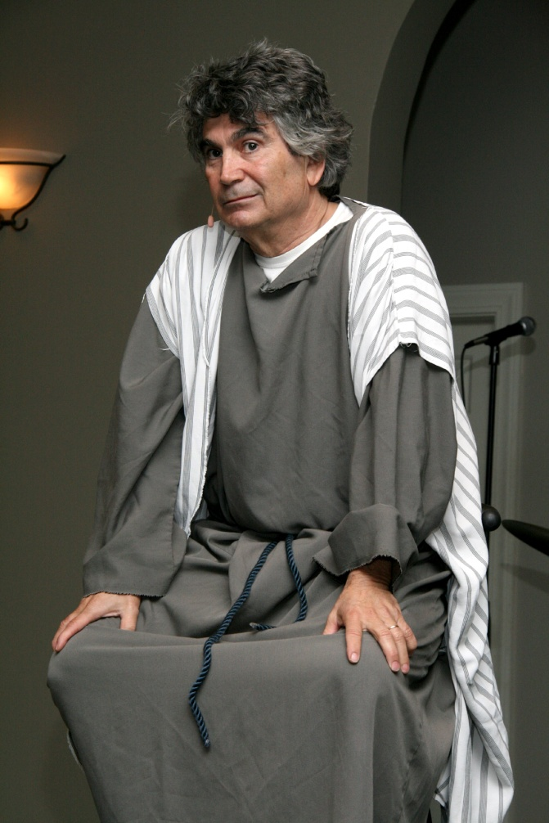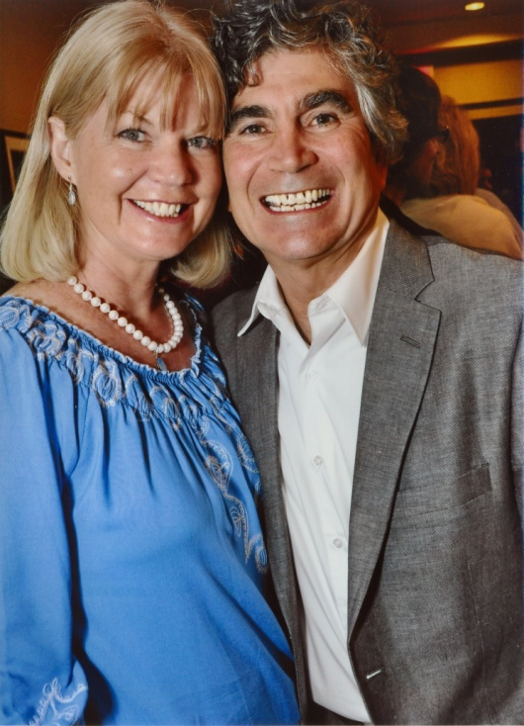

“The Book of James”

Dennis Cole as

James,

The brother of Jesus

We have all read that “faith without works is dead”.

Your info here

Place, time, date

Phone, etc.

Or if you prefer, you

Can delete this text box and

Stretch the picture of Dennis to fill the space

***http://dcministries.com***

***Albuquerque, NM***

***Enter through the narrow gate. For wide is the gate and broad is the way that leads to destruction, and many enter through it. But small is the gate and narrow the way that leads to life, and only a few find it.  - Matthew 7:13-14***

***Wendy & Dennis Cole***

Bible Drama, Theater, Film, Radio, TV, Scripts, Acting School

For more information visit our website

**Dramatic Christian Ministries**

**~ Narrow Gate Theater ~**

The Acts of the Holy Spirit ~ Transforming Lives